|  |
| --- |
| **Watercolor pastel colored crystal** |

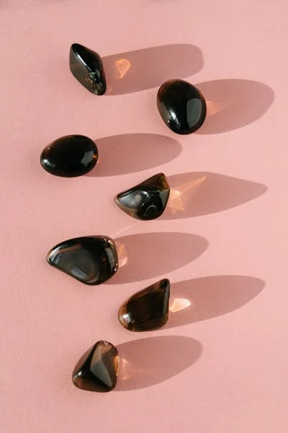

Watercolor pastel-colored crystals have soft, translucent hues and are often associated with gentle, calming energies. These stones are believed to promote emotional healing, creativity, and inner peace, making them perfect for meditation and energy work.